1. Your name - both as in the roster and how you preferred to be called.

Name: Shahab Geravesh

The preferred name is the same as the Name.

1. Your photo - clear enough to easily see your face (i.e. at least 2"x2").

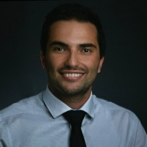

1. What programming experience you have?

I have a MS degree from UC Riverside in Data Science engineering. I am fluent in Python, JavaScript, and some JS frameworks (React, Angular).

1. Is this experience only classroom-based or in a corporate/professional setting or both?

Mostly classroom based.

1. Any experience with OOP using Java, C++, Python, C#, or Swift?

I am fluent in Python but never used it in a professional setting since my current role is Portfolio Management at an investment bank.

1. Any UI design experience - web development, Visual Basic etc.?

I completed the UC Berkley web development Bootcamp. I designed and created some websites from scratch without using any templates.

1. Any experience with mobile apps development - iOS or Android?

No.

1. Your objective for taking this class, i.e., what do you hope to get out of the course?

I’d like to launch my own app and have a better understanding of App development at the end of the course.

1. Are you a full-time student (i.e., not working outside school) or working part-time or full time while attending school?

I am a part-time student and working full time. I took this class solely to pursue my passion.

1. Anything you would like to share that could improve your personal success in the course?

I learn more if the class follows a hands-on model as opposed to teaching and observing. I am hoping that I publish my own application at the end of the course.